Date: 27.12.2024
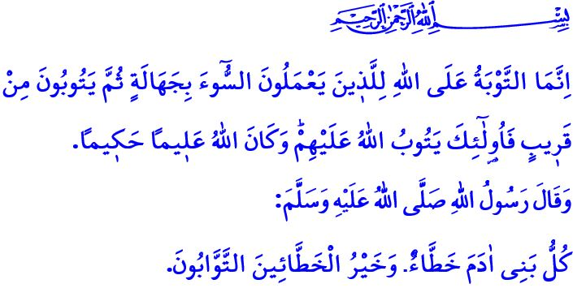
THE BEST OF THOSE WHO COMMIT SIN ARE THOSE WHO REPENT
Dear Muslims!
Once again, we find ourselves in the final days of yet another year of the Gregorian calendar. The new year is bringing with it an abundance of blessings. The first day of the new year also marks the beginning of the Three Holy Months, a season of mercy and forgiveness. Next Thursday evening, we will be observing the Lailat al-Raghaib, inshallah. Endless praise and thanks be to our Almighty Lord (swt), Who has brought us to these blessed days once again. Salat and salam be upon His messenger of mercy, Prophet Muhammad Mustafa (saw). I wish you a blessed month of Rajab and Lailat al-Raghaib from now.
Dear Believers!
Our life capital is rapidly running out. Every minute that passes brings us closer to death. While this is the case, we sometimes forget our covenant of servitude and neglect our responsibilities towards our Lord (swt), our family, our environment, and humanity. Sometimes, we also overlook the Day of Reckoning; we pollute our inner world with mistakes and wrongdoings. However, our Almighty Lord (swt) advises us to value every moment, to account for our past, and to plan our future with goodness and righteousness. Through the verse, “O believers! Be mindful of Allah and let every soul look to what ˹deeds˺ it has sent forth for tomorrow.”, He commands us to prepare for the eternal world with faith, worship, and good morals, and to repent for our mistakes and sins.
Dear Muslims!
One of the blessings that our Almighty Lord (swt) has bestowed on His servants is the gift of repentance. Repentance is a form of worship that dates back to the beginning of humanity. All the prophets, from the Prophet Adam onwards, both repented themselves and called their ummahs to repent. Repentance is to feel regret, to return to one’s essence and original nature. It is the servant’s turning towards his Lord (swt), seeking forgiveness. Through the verse, وَتُوبُٓوا اِلَى اللّٰهِ جَم۪يعاً اَيُّهَ الْمُؤْمِنُونَ لَعَلَّكُمْ تُفْلِحُونَ “O believers! Turn to Allah in repentance all together so that you may be successful.”, Allah the Almighty (swt) calls on us to repent. So, let us spend these days in repentance and reflection as we enter the blessed climate of the Three Holy Months. Let us resolve not to make the same mistakes again.
Esteemed Believers!
Let us repent to our Lord (swt) if we have neglected our duties of servitude, as ordered by our sublime religion, Islam. If we have acts of worship that we could not perform on time, let us complete them as soon as possible. Let us never forget the warning, وَاعْبُدْ رَبَّكَ حَتّٰى يَأْتِيَكَ الْيَق۪ينُ “and worship your Lord until the inevitable comes your way.”
If we have hurt our family with our words and behaviors, if we have left our children, who are created with a pure nature, at the mercy of the wrongdoers, if we have disrespected our parents, to whom it is forbidden to even say ‘ugh’, let us ask for forgiveness from Allah.
If we have polluted our tongues with evil deeds such as backbiting, gossip, and insults; if we have darkened our hearts with evil deeds such as arrogance, pride, and envy; if we have engaged in harams such as alcohol, gambling, interest, and violated the rights of others and the public; if we have made unfair gains through sins such as bribery, stockpiling, and black marketeering, let us repent without wasting any time.
If we have violated the boundaries of privacy, whether in real life or in the virtual environment; if we have lied and slandered the honor and dignity of people with lies and false accusations, let us ask for forgiveness from our Lord (swt) without delay.
Let us repent immediately if we have severed good relations with our relatives, caused inconvenience to our neighbors, violated the rights of the motherless and fatherless, and the vulnerable, or used harsh words and brute force in traffic, the workplace, or the marketplace.
In short, let us make up for the rights of all those who have rights over us, reconcile with those we have wronged, and sincerely seek forgiveness from Allah (swt).
Dear Muslims!
No matter how numerous our sins may be, the mercy of our Lord (swt) encompasses the entire universe. The door of repentance to Him is always wide open. In one of his hadiths, the Messenger of Allah (saw) says, “Every son of Adam commits sin, and the best of those who commit sin are those who repent.” So let us take account of our deeds now, before the Day of Judgement, when mouths will be sealed, and hands, feet, and skins will bear witness to what they have done. Let us reckon with ourselves before we are reckoned. Let us seek forgiveness and pardon from our Lord (swt) for all the mistakes and sins we have committed. Let us not forget that repentance in the last minute holds no value in the sight of Allah (swt).
I would like to conclude this Friday’s khutbah with the meaning of the following verse from the Surah al-Nisa: “Allah only accepts the repentance of those who commit evil ignorantly ˹or recklessly˺ then repent soon after— Allah will pardon them. And Allah is All-Knowing, All-Wise.”

Hashr, 59/18.
Nur, 24/31.
Hijr, 15/99.
Ibn Majah, Zuhd, 30.
Nisa, 4/17. General Directorate of Religious Services

